Henry W. Fromme Family

A pioneer family of Kiowa County was that of Henry W. Fromme, who was born in Langenholzhausen, Lippedetmoldt Germany, Oct. 19th, 1858. He immigrated to America at the age of 21, often recalling to his family that he arrived in Kiowa County with less than a dollar. From New York he worked his way west and spent about six months in the Chicago area, and about 4 years in Missouri before taking advantage of the homestead opportunities in Kansas. He chose s site about five miles Southwest of what is now Mullinville and filed under the homestead act.

At that time the Rock Island railroad had not progressed that far west and all supplies had to be hauled from Kinsley on the Sana Fe, and some of the equipment had to be hauled out from Kingman. Kinsley was then the nearest railroad point.

In the sparsely settled region where he homesteaded, he became acquainted with Miss Mary Lammers, the daughter of Herman and Mary Lammers who were themselves immigrants from Holland. They first located in Cole County Missouri where Miss Mary was born May 31st,1870. The Lammers family emigrated to a farm near what is now Haviland, where the young bachelor started his courtship often driving a white blind mule hitched to a buggy.

The romance blossomed and Henry and Mary were married on July 21st, 1890. To this union Edward H., Olia N., Moritz P., Roxie R., Violet E., and Roosevelt H. The six children were born without the services of a doctor, but with the attention of a neighbor lady acting as a midwife. At the time of this writing, Oct. 1978 two of the six children are still living: Olia N. Christopher, Bucklin, and Roosevelt H. Fromme, Plains, Kansas.

By their labor, careful planning and conservation of resources, the family accumulated 2800 acres of good farm land with nine good sets of improvements. Eight sets of improvements were rented to other farmers whom Henry helped start to financial security, often lending them essential machinery and horses with which to start farming.

The first family dwelling which was burned was replaced about 1903 by a large two story house which was equipped with all of the modern conveniences as they became available, such as running water, a bathroom and carbide lights. Later in 1912 to care for the increasing number of horses with which to farm, a large round barn 86 ft. in diameter was built to stall 28 draft horses and a box stall for the registered Percheron stallion which he imported from France. This round barn became a landmark, is still standing and is much photographed and painted by artists. It took many carloads of lumber to build, which was all hauled from Mullinville with team and wagon.
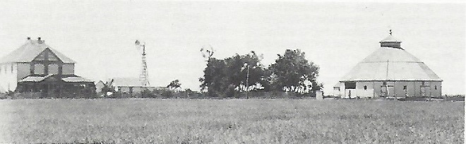

Mr. Fromme was always interested in progress and willing to try any new improvements in farming. He owned the second automobile delivered to Kiowa County which was a high wheeled, chain driven, Model F. Buick. The engine placed horizontally under the chassis had to be cranked from the right side of the car instead of the front as the later model engines were made. It was equipped with carbide lights which had the gas generator on the left running board to be filled with carbide and water before each drive taken at night. The tail light was kerosene fueled.

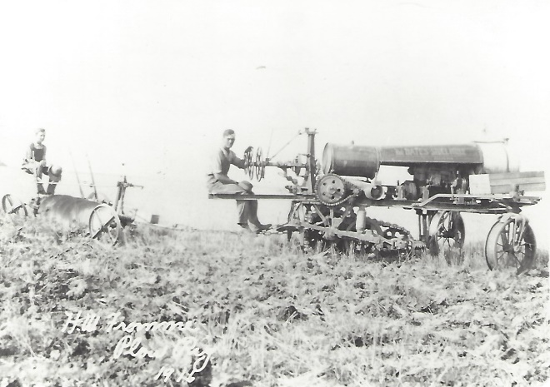
Moritz Fromme on the “tractor” with brother Ted on the “plow” – 1916

Mr. Fromme owned one of the first tractors in the area, which was known as the Bates Steel Mule. It had two wheels in front and was driven by a single track device similar to the present Caterpillar tractors. This arrangement was extremely difficult to turn and this type of power was soon replaced by the more modern 4-wheel tractors. Mr. Fromme also owned one of the first combine harvesters which replace the older method of harvesting with grain binder or header. The motive power for this combine was team of eight horses hitched in tandem, two abreast. This arrangement was also ungainly and difficult to turn corners. The driver had to handle four sets of lines to guide the horses.

Being progressive and civic mind, Mr. Fromme was a stockholder and vice president of the Citizens State Bank, Mullinville, which later consolidated with the Mullinville State Bank, to then be called the First State Bank. He was also a stockholder and vice president of the Farmers State Bank, Bucklin, until it was sold to the Collingwood family in 1918 who still own and operate it. Mr. Fromme also served his community for 8 years by accepting the voter’s will as County Commissioner of the 3rd district in Kiowa County. He was a commissioner when the present courthouse was built and his name, with the tow other commissioners is engraved on the cornerstone on the North side of the courthouse.
When Henry’s second son, Moritz Fromme, returned from overseas duty after World War One in 1918 he turned the farming operation of the home place to Moritz and moved his wife and two remaining single children to a lovely home in Bucklin where the family resided until his death on Dec. 9th, 1922, at the age of 64 years. His wife, Mary, his helpmate and mother of his children survived him until 1948 when she went to join her husband at the age of 78 years.

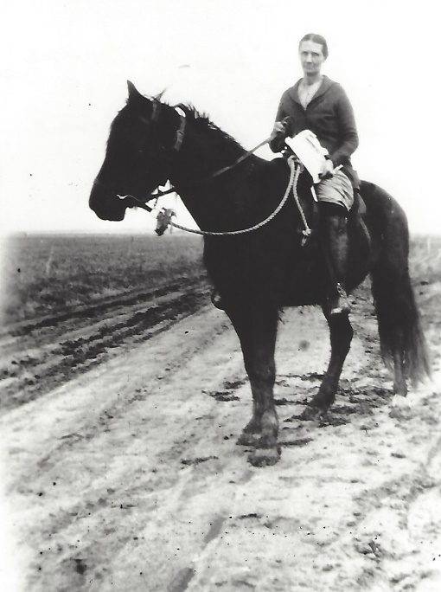
Mary Lammers Fromme, wife of H.W. (Henry) Fromme

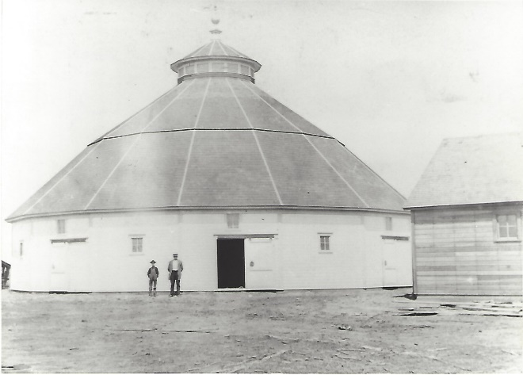
H.W. Fromme and son Moritz

(Source: Kiowa County History Book, 1979 & A History of Kiowa County, Vol. II)

